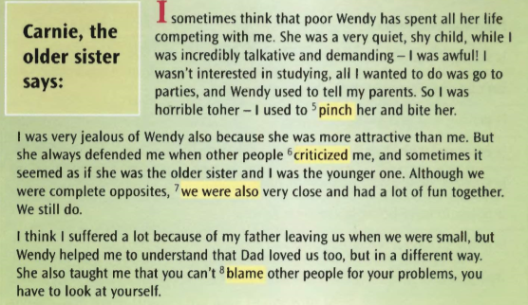
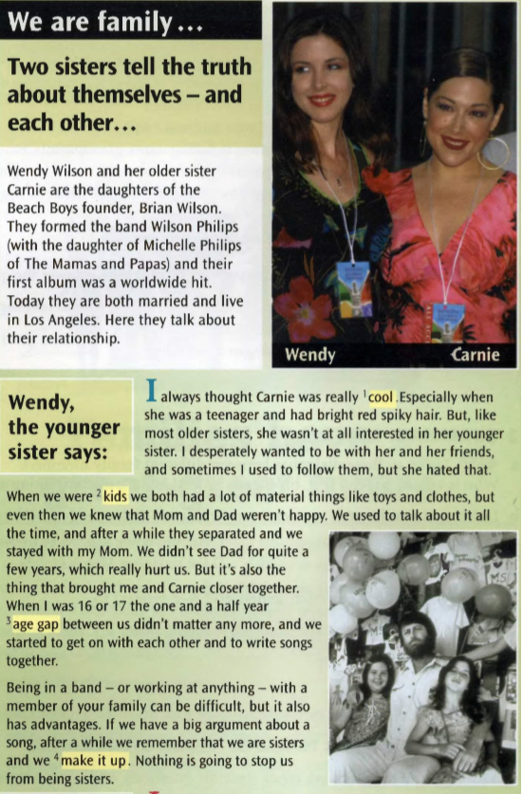
1. Reading comprehension : sisters ! Read the text and answer the questions
→ Exercise 1 : Look at the highlighted words and phrases. Choose the right meaning : a or b ?
1. | a. boring  b. fashionable
2. | a. children  b. adults
3. | a. age difference  b. the time they weren’t together
4. | a. become friends again  b. stop speaking
5. | a. a kiss  b. hurt with your fingers
6. | a. say bad things about  b. say good things about
7. | a. we get on very well  b. we get on very badly
8. | a. ask for help  b. say that somebady is responsible for somthing bad

→ Exercise 2 : choose between the two sisters
Who do you think ….
had a more eccentric hairstyle ?
admired her sister ?
didn’t want to be with her sister ?
tried to compete with her sister ?
wasn’t a good student ?
told her parents when her sister did something wrong ?
used to hurt her sister physically ?
was jealous of her sister ?
always defended the other sister ?

