ROUND 2

À la fin du Round 2 « What’s your daily routine ? » tu seras capable de :

- comprendre des informations essentielles dans un message écrit en rapport avec les activités quotidiennes d’autrui.
(Lire pour s’informer)

- produire un message écrit pour décrire sa journée type.
(Écrire pour informer)

2.1. LISTENING COMPREHENSION: This is my life

Contexte : Dans le cadre d’un échange linguistique, tu t’apprêtes à te rendre en Angleterre. Tu décides donc de regarder des vidéos afin voir à quoi ressemble le quotidien des jeunes anglais.
- Fred’s daily routine
Tâche : Regarde la vidéo de Fred parler de sa routine et donne 12 d’informations à propos de son quotidien.

Scanne le QRcode afin d’avoir accès à la vidéo.

La routine de Fred
- …………………………………………………………………………………………………………………….
- …………………………………………………………………………………………………………………….
- …………………………………………………………………………………………………………………….
- …………………………………………………………………………………………………………………….
- …………………………………………………………………………………………………………………….
- …………………………………………………………………………………………………………………….
- …………………………………………………………………………………………………………………….
- …………………………………………………………………………………………………………………….
- …………………………………………………………………………………………………………………….
- …………………………………………………………………………………………………………………….
- …………………………………………………………………………………………………………………….
- …………………………………………………………………………………………………………………….

- Ecoute à nouveau la journée de Fred et suis avec le texte.
“My name is Fred, I live in London and I’m 17 years old. I wake up at 7 and I usually get out of bed about 7.30. Then I come downstairs and have breakfast. Usually I have cereal for breakfast and orange juice but sometimes I have a toast with usually jam or honey. Then I pack my bag for school. I walk, because my school is only in the centre of the town where I live. So, it’s only 15 minutes’ walk in the morning, which is good because it means I can sleep later. The school is quite old. It’s been a school for about 400 years and it’s got about a 1000 student there in 7 age groups and it’s only boys there. School starts at 8.30 and then we have 2 lessons which go until 10.15. At 10.45 we have 15 minutes break. Then 11 until 12.40 we have two more lessons and then lunchtime. I can go into town to get my lunch but most people have to stay in the school and eat the school food. British school food isn’t very nice. Then we have 2 more lessons after lunch and we finish school at 3.30. Usually I come home and I just sort of relax for a bit and that’s usually for maybe an hour. I read or I watch television… My mum gets about usually half past five and six so we usually eat dinner at about six thirty.”

2.3. Vocabulary exercises

- Match the actions with the pictures.
- Watch T.V. 6. Get dressed 11. Listen to music
- Have breakfast 7. Wake up 12. Get home
- Get up 8. Have a shower 13. Go to school
- Go out with friends 9. Brush my teeth 14. Go to bed
- Play on the computer 10. Do my homework 15. Take the bus

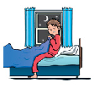
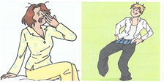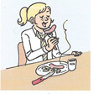
A B C D

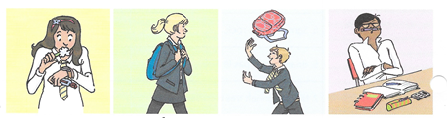
E F G H

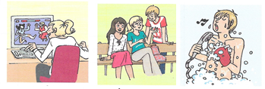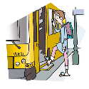
I J K L

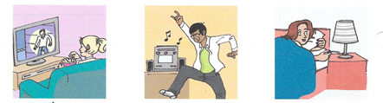
M N O

A | B | C | D | E | F | G | H | I | J | K | L | M | N | O

2.4. Reading comprehension : Eric’s Life
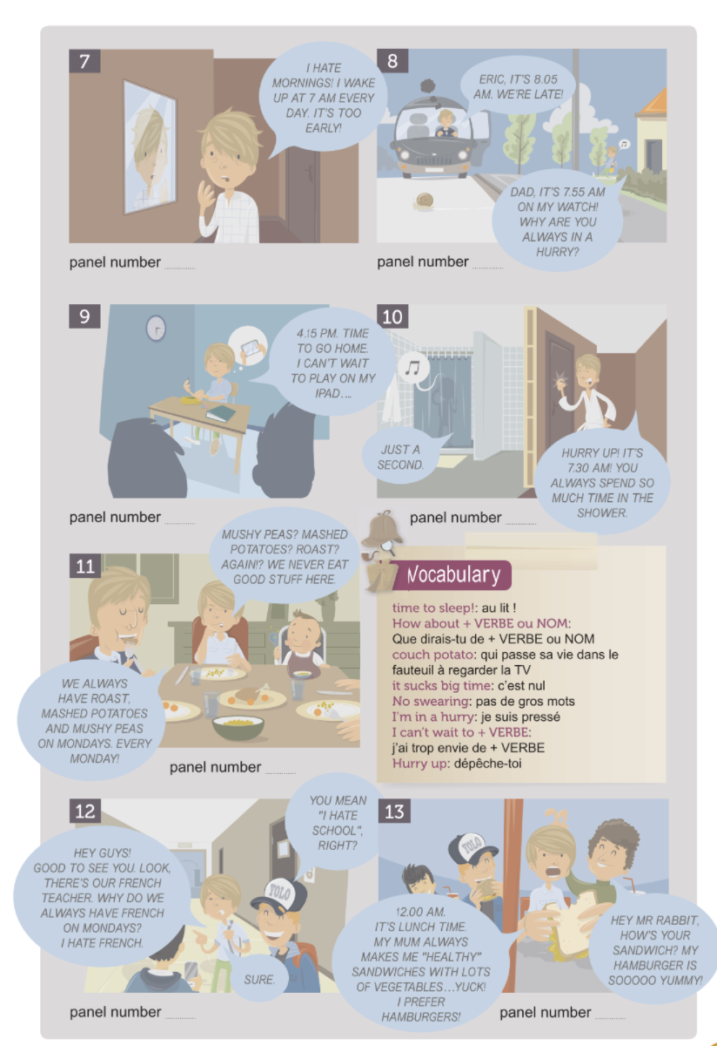
Find out what Eric’s life is like.
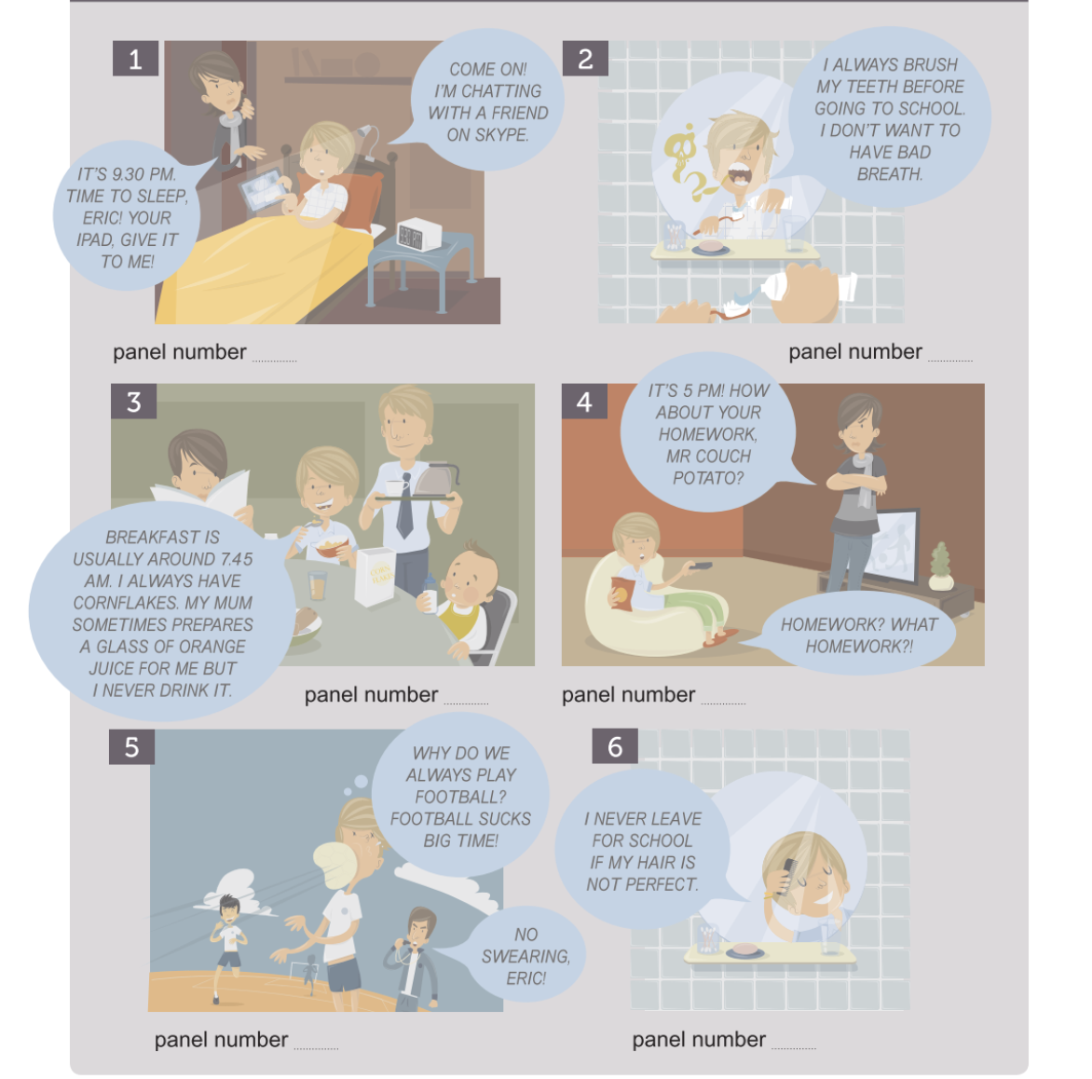
- Remets l’histoire dans l’ordre.( de 1 à 13)

- Match Column A with column B

A |  | B
1) It’s 9.30 PM. Time to sleep, Eric.  2) Breakfast is usually around 7.45 AM  3) I wake up at 7 AM every day.  4) Eric, it’s 8.05 AM, we’re late!  5) Dad it’s 7.55 AM on my watch!  6)4.15 PM. Time to go home.  7) It’s 7.30 AM! You always spend so much time in the shower.  8) 12.00 AM. It’s lunch time. |  | A) A quarter past four (in the afternoon).  B) Half past nine (in the evening).  C) Seven o’clock (in the morning).  D) Five past eight (in the morning).  E) Half past seven (in the morning).  F) Five to eight (in the morning).  G) A quarter to eight (in the morning).  H) It’s twelve o’clock (at noon)

1 | 2 | 3 | 4 | 5 | 6 | 7 | 8
- Write 5 sentences about your daily routine and give information about the time.
- At __________________________________________________
- At __________________________________________________
- _____________________________________________________
- _____________________________________________________
- _____________________________________________________

  - Synthèse : Telling the time

Pour donner l’heure en anglais, on utilise les nombres de 1 à 12 même pour les heures de l’après-midi. Pour les différencier, on se sert des abréviations AM et PM. En anglais, on indique les minutes avant les heures.
AM =_________ PM = _________
- L’heure pile:
- I wake up at seven o’clock every day.
- I have lunch at twelve o’clock.
- On utilise _______________ uniquement pour _________________.

- « to » et « past »
- It’s five past eight! We’re late!
- Dad, it’s five to eight on my watch!
- On utilise __________ pour les minutes _________ l’heure.
- On utilise __________ pour les minutes _________ l’heure.

- La demi- heure :
- It’s half past nine, it’s time to sleep!
- It’s half past seven! You always spend so much time in the shower.
- On utilise __________________ pour la ___________________.

- Les heures 15 et 45 :
- Breakfast is usually around quarter to eight.
- On utilise ________________ pour le quart d’heure ________ l’heure.

- School finishes at quarter past four.
- On utilise ________________ pour le quart d’heure ________ l’heure.
Remarque → L’heure peut également se dire de façon numérique
10 :30 = ____________ 8.15 = ____________ 7.42 = ___________

- Complète l’horloge :
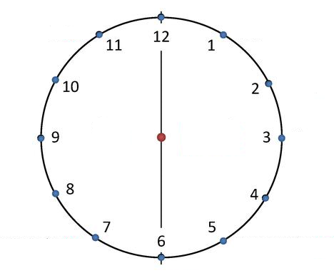

- Quelques expressions utiles :
What time is it? → ____________________________
What time do you get up? → ____________________________
It’s 9 o’clock → ____________________________
At 9 o’clock → ____________________________
From 6 to 8 o’clock → ____________________________
- What time is it in these cities when it’s 12 AM in Liège?

Manchester? ___________ Toronto? __________
Los Angeles? _________ Sydney? ____________

- That is the time difference → Le _______________

2.6 What time is it? exercises

- Write the correct hour.

- Write these hours in letters

- Il est 13h05: __________________________________________

- À 3h20: _____________________________________________

- Il est 22h25: __________________________________________

- À 18h45: ____________________________________________

- Il est 5h 55: __________________________________________

- À 8h10: _____________________________________________

Oral exercises:
- Answer the following questions in English.

What time do you get up? ___________________________________
What time is your bus/train? _________________________________
What time do you leave home? ________________________________
What time is your first lesson? ________________________________
What time is your last lesson? _________________________________
What time do you have lunch? ________________________________
What time is your bus to go back home? __________________________
What time do you go to bed? __________________________________

