Exercices supplémentaires
- Réduis si possible les expressions suivantes
2a . 3b = ………………….. | 5x² - 3x² = ………………….. | 3b . ( -b²) = …………………….
2a . (-3b) = ……………….. | 4x – x = …………………….. | 3b – b² = ……………………….
-4a – 2a = …………………. | -2x² - 3x² = ………………… | -3b – b = ……………………….
2a – 3b = …………………. | 3a – 2b = …………………… | - b² + 2b² = …………………….
-2a + 3a = …………………. | 3b² - b² = …………………… | 4a + 4a = ……………………….
- Complète les égalités

15a = 5a + ……………… | 6a = 6a + ……………….. | 8a² = 2a . ……………….
20a = 5a . ……………… | 4a = 5a - ………………… | 10 a²b = 5ab . ……………
8a = -4 . ………………. | - 4a = 4a . ………………. | 36 b² = 9 . ………………..

- Réduis les expressions qui peuvent l’être

2a . ( -3b) = …………………….. | 8xy² - ax + 5 + 8ax – 3xy² = ………..………
- 4a . (-2b) = ……………………. | 4a² . (-2x) . (-6x) = ………………………….
-4a . 2c . (-5b) = ……………….. | 5a² - 3b + 7a – a² + 5b = …………………….
-4ab – 2a + 3ab – a = …………………………… | 3a . a² . 5b² . (-2x) = …………………………
- 7a² - ab + 3a² + 5ab = …………………………. | 6a . ( - 4x) – (-8x) . 2a = …………………….

- Calcule les valeurs numériques des expressions suivantes

a = -3 b = -2 c = 4 d = 5

- a + b + c + d =
- ab + cd =
- ac – bd =
- a – c – d + b =
- (a + b) – (c – d) =
- (d – c) .(a – b) =
- ac + bd =
- a + c . b + d =
- a . b . c . d =
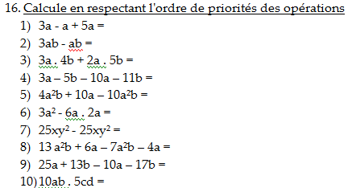
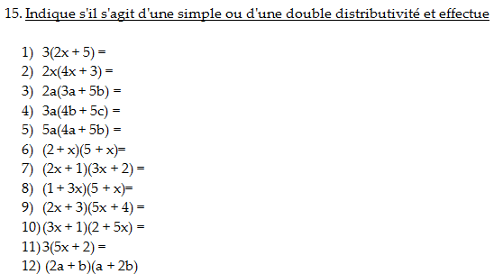
- 2a + + 4(c + d) =

